Lesson #

Christology-The Ascension of Christ

15

Lesson Commenced: ____________________ Lesson Completed: ____________________

* While we have been learning about the Person and Work of Christ, we need to have a lesson devoted to the Ascension of the Lord Jesus. The Ascension is one of the main doctrines that deals with His present state.

* The life of the Lord Jesus Christ can be told as four great miracles. *The Incarnation*, *the Resurrection*, *the Ascension*, and *the Second Coming*. These are the four main parts of His life.

The Manner of the Ascension

**The Ascension was *Bodily and Visible***

The Ascension is the event in ***Acts 1*** when Christ departed visibly and returned to heaven. We are told in our Bibles that the Lord did ascend to heaven one time before this time we are discussing, temporarily, but returned in a matter of hours back to earth. This was the ascension that He told Mary not to touch Him yet. ***John 20:10-17*** The difference in the first time and the one that we are studying in this lesson is that after the second ascension the Lord did not return. He is seated at the right hand of the Father now and we are waiting for Him.

“Looking u _ _ _ J _ _ _ _ the a _ _ _ _ _ and f _ _ _ _ _ _ _ of o _ _ f _ _ _ _; who for the joy that was set before him endured the cross, despising the shame, and i _ s _ _ d _ _ _ at t _ _ r _ _ _ _ h _ _ _ of the t _ _ _ _ _ of G _ _.” ***Hebrews 12:2***

Christ came to this earth as a humble baby. He left this earth as an exalted conqueror. When His earthly work was completed, He entered into His heavenly ministry of preparing the mansions and His high priestly work of interceding on our behalf.

“And when he had spoken these things, w _ _ _ _ t _ _ _ b _ _ _ _ _, he was taken up; and a cloud received him o _ _ o _ t _ _ _ _ s _ _ _ _. And while t _ _ _ l _ _ _ _ _ stedfastly toward heaven as he went up, behold, two men stood by them in white apparel; Which also said, Ye men of Galilee, why s _ _ _ _ y _ g _ _ _ _ _ up into heaven? this same Jesus, which is taken up from you into heaven, shall so come i _ l _ _ _ m _ _ _ _ _ as y _ h _ _ _ s _ _ _ him go into heaven.” ***Acts 1:9-11***

The Lord’s Ascension was both bodily and visible to the human eye.

* **The Ascension *was prophesied and taught throughout the entire Bible.***

“Thou hast a _ _ _ _ _ _ _ o _ h _ _ _, thou hast led captivity captive: thou hast received gifts for men; yea, for the rebellious also, that the LORD God might dwell among them.” ***Psalms 68:18***

“The L _ _ _ said unto m _ L _ _ _, S _ _ t _ _ _ a _ m _ r _ _ _ _ h _ _ _, until I make thine enemies thy footstool.” ***Psalms 110:1***

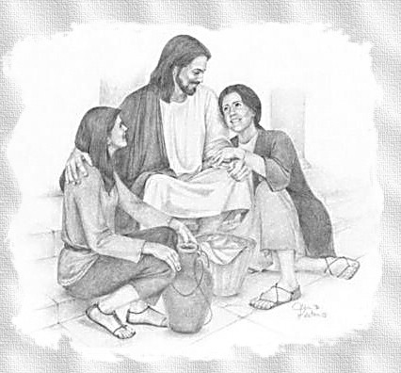

“And i _ c _ _ _ t _ p _ _ _, when the t _ _ _ w _ _ c _ _ _ that h _ s _ _ _ _ _ b _

r _ _ _ _ _ _ _ u _, he stedfastly set his face to go to Jerusalem,” ***Luke 9:51***

“What and if y _ s _ _ _ _ s _ _ the Son of man a _ _ _ _ _ u _ w _ _ _ _ h _ w _ _

b _ _ _ _ _?” ***John 6:62***

“Ye have heard how I said unto you, I g _ a _ _ _, and come again unto you. If ye loved me, ye would rejoice, because I said, I g _ u _ _ _ t _ _ F _ _ _ _ _: for my Father is greater than I.” ***John 14:28***

“Jesus saith unto her, Touch me not; for I am not yet a _ _ _ _ _ _ _ t _ m _ F _ _ _ _ _: but go to my brethren, a _ _ s _ _ unto them, I a _ _ _ _ _ u _ _ _ m _ F _ _ _ _ _, and your Father; and t _ m _ G _ _, and your God.” ***John 20:17***

The Old Testament spoke of the ascension, and Jesus taught it openly and freely. The disciples did not understand it any more than they understood the precious truths of His death, burial, and resurrection, but with what truth they had they believed, and came to experience it. We have the completed word of the living God and have no excuse for not believing. Let us go believing.

* **The Ascension *occurred forty days after the resurrection***

The Lord Jesus Christ delayed going back to the Father in order to prove beyond a shadow of a doubt that He had actually risen from the dead. This was essential for establishment of faith to the believer. Here was a man who lived historically and died historically, and who was seen by five hundred witnesses, and then kept up His testimony for forty days, so there couldn’t be any question about the matter. Jesus also tarried to give the disciples more instruction on the Christian faith. He was able to explain much of His past teaching to the disciples in light of that which had recently occurred, His own death, burial, and resurrection.

“To whom also h _ s _ _ _ _ _ h _ _ _ _ _ _ a _ _ _ _ after h _ _ p _ _ _ _ _ _ by m _ _ _

i _ _ _ _ _ _ _ _ _ p _ _ _ _ _, being s _ _ _ of them forty days, and s _ _ _ _ _ _ _ of the things pertaining to the kingdom of God:” ***Acts 1:3***

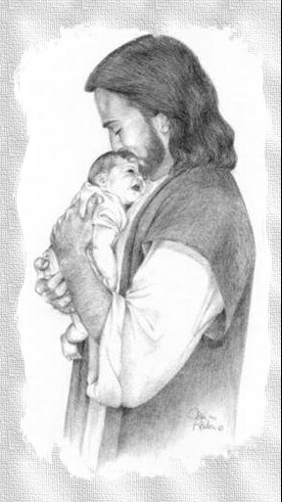If it is *infallible* then it is *absolute, dogmatic, authoritative*, and cannot be denied or abrogated. We should not be arguing with skeptic’s who try to rob us of our faith. We know the truth and believe, they are the ignorant ones.

“If a _ _ m _ _ think himself to be a prophet, or s _ _ _ _ _ _ _ _, let him

a _ _ _ _ _ _ _ _ _ _ that the things t _ _ _ I w _ _ _ _ unto you are the

c _ _ _ _ _ _ _ _ _ _ _ of t _ _ L _ _ _. But if any man b _ i _ _ _ _ _ _ _, l _ _ h _ _

be i _ _ _ _ _ _ _.” ***1 Corinthians 14:37, 38***

* **The Ascension was Imperative to *the Holy Ghost Coming to indwell the believer***

The divine plan was that the Holy Ghost would not come to indwell the believer until after the ascension of the Lord Jesus Christ.

“Nevertheless I tell you t _ _ t _ _ _ _; It is e _ _ _ _ _ _ _ _ f _ _ y _ _ that I g _a _ _ _: for if I go not away, the C _ _ _ _ _ _ _ _ w _ _ _ n _ _ c _ _ _ unto you; but if I depart, I w _ _ _ s _ _ _ h _ _ unto you.” ***John 16:7***

* **The Ascension had to be *a prior condition for Him to go and prepare a place for us***

It would have been wonderful if Jesus could have lived on this earth forever in His post-resurrection power, but that was not the plan of God for the Church. The plan of God for the Church was for the Holy Ghost to come and dwell in the believer so that believers would be scattered all over the earth and do what the Lord wanted done worldwide. That is probably the most sought-after desire of all humans, young and old, is to finally ***“have and know their PLACE in creation.”*** Isn’t it wonderful to know that Jesus has promised us “…a ***PLACE*** for you?”

“In my Father’s house are many mansions: if it were not so, I would have told you. I go

t _ p _ _ _ _ _ _ a p _ _ _ _ f _ _ y _ _. And if I go and prepare a place for you, I w _ _ _

c _ _ _ a _ _ _ _, and r _ _ _ _ _ _ y _ _ unto myself; that where I am, t _ _ _ _ y _ m _ _

b _ also.” ***John 14:2, 3***

* **The Ascension *had to complete Christs redemptive work that was required***

“Jesus saith unto her, Touch me not; for I a _ n _ _ y _ _ a _ _ _ _ _ _ _ t _ m _

F _ _ _ _ _: but go to my brethren, a _ _ s _ _ unto them, I a _ _ _ _ _ u _ _ _ m _

F _ _ _ _ _, and your Father; and t _ m _ G _ _, and your God.” ***John 20:17***

* **The Ascension *enabled His followers to do the promised greater work***

“Verily, verily, I say unto you, He that believeth on me, the w _ _ _ _ that I d _ s _ _ _ _

h _ d _ a _ _ _; and g _ _ _ _ _ _ w _ _ _ _ than these shall he do; because I go unto my Father.” ***John 14:12***

* **The Ascension *made the Lord’s ministry world wide***

“Go ye therefore, and t _ _ _ _ a _ _ n _ _ _ _ _ _, baptizing them in the name of the Father, and of the Son, and of the Holy Ghost:” ***Matthew 28:19***

***­***I am glad that the Gospel reached me, aren’t you? What a beautiful gift? The

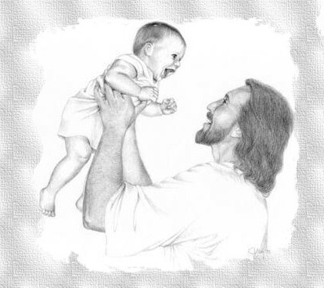Ascension is a strong proof and an explanation of the resurrection body of the Lord. Amen!

The Purpose of The Ascension

* **The Lord Jesus Christ ascended *to glorify the Father***

“These w _ _ _ _ s _ _ _ _ J _ _ _ _, and lifted up his eyes to heaven, and said,

F _ _ _ _ _, the hour is come; glorify thy Son, t _ _ _ t _ _ S _ _ a _ _ _ m _ _

g _ _ _ _ _ _ t _ _ _:” ***John 17:1***

* **The Lord Jesus Christ ascended *to become “a Prince and a Savior” to Israel***

“H _ _ h _ _ _ G _ _ e _ _ _ _ _ _ with his right hand t _ b _ a P _ _ _ _ _ a _ _ a

S _ _ _ _ _, for to give repentance t _ I _ _ _ _ _, and forgiveness of sins.” ***Acts 5:31***

* **The Lord Jesus Christ ascended *as a forerunner, opening the pathway for us***

“Whither the f _ _ _ _ _ _ _ _ _ is f _ _ u _ e _ _ _ _ _ _, e _ _ _ J _ _ _ _, made an high priest for ever after the order of Melchisedec.” ***Hebrews 6:20***

* **Jesus ascended *to prepare our heavenly abode***

“In my Father’s house are many mansions: if it were not so, I would have told you. I g _

t _ p _ _ _ _ _ _ a p _ _ _ _ f _ _ y _ _.” ***John 14:2***

* **The Lord ascended *to be our High Priest***

“And h _ _ _ _ _ a _ h _ _ _ p _ _ _ _ _ o _ _ _ the h _ _ _ _ o _ G _ _;” ***Hebrews 10:21***

* **The Lord ascended *to take His appropriate place at the right hand of God in glory***

“But t _ _ _ m _ _, after he had offered one sacrifice for sins for ever, s _ _ d _ _ _ o _

t _ _ r _ _ _ _ h _ _ _ o _ G _ _; From henceforth expecting till his enemies be made his footstool.” ***Hebrews 10:12, 13***

* Furthermore, the Lord Jesus Christ is the only person who ever “ascended”. We know from reading our Bibles that Moses was taken up after he died. ***Jude 9***; ***Deuteronomy 34***. We know that Elijah was caught up in a chariot of fire in a whirlwind. ***2 Kings 2*** We know that Enoch was translated that he should not see death. ***Genesis 5***; ***Hebrews 11*** The word “ascend” means to go up under your own power. The devil made a statement about ascending, and the Lord replied to it.

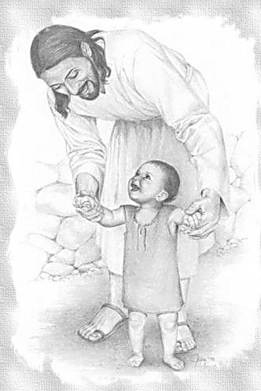“I w _ _ _ a _ _ _ _ _ a _ _ _ _ the h _ _ _ _ _ _ of t _ _ c _ _ _ _ _; I will be like the most High.” ***Isaiah 14:14***

“Yet t _ _ _ s _ _ _ _ b _ b _ _ _ _ _ _ d _ _ _ t _ h _ _ _, to the sides of the pit. ***Isaiah 14:15***

* The Lord Jesus Christ spoke to Nicodemus about ascension.

“And n _ m _ _ h _ _ _ a _ _ _ _ _ _ _ u _ t _ h _ _ _ _ _, b _ _ h _ t _ _ _ c _ _ _ d _ _ _ f _ _ _ h _ _ _ _ _, even the S _ _ o _ m _ _ which is in heaven.” ***John 3:13***

Praise the Lord for His infinite wisdom!

The Results of the Ascension

* **A Result is that *Christ gave gifts to men***

“Wherefore he saith, W _ _ _ h _ a _ _ _ _ _ _ _ u _ o _ h _ _ _, he led captivity captive, and g _ _ _ g _ _ _ _ u _ _ _ m _ _.” ***Ephesians 4:8***

* **Because Jesus Ascended *the Holy Ghost Descended***

“Therefore being by the right hand of God exalted, and h _ _ _ _ _ r _ _ _ _ _ _ _ o _ t _ _ F _ _ _ _ _ t _ _ p _ _ _ _ _ _ of t _ _ H _ _ _ G _ _ _ _, he hath shed forth this, which ye now see and hear.” ***Acts 2:33***

* **By Ascending, *He demonstrated that the sins were purged by sitting down, showing completed action***

“Who being the brightness of his glory, and the express image of his person, and upholding all things by the word of his power, w _ _ _ h _ h _ _ b _ h _ _ _ _ _ _

p _ _ _ _ _ o _ _ s _ _ _, s _ _ d _ _ _ on the right hand of the Majesty on high:”

***Hebrews 1:3***

This is very significant in view of the fact that throughout the Old Testament, when the Tabernacle was standing, the priests who ministered in the Tabernacle could never sit, clearly indicating their work was never finished. Our High Priest, when He finished the blood atonement, “sat down” clearly indicating that our salvation was finished. If it was not complete the High Priest would not have sat down.

* **Because Christ Ascended, *we can now come boldly to Him in prayer***

“L _ _ u _ therefore c _ _ _ b _ _ _ _ _ unto the t _ _ _ _ _ o _ g _ _ _ _, that we may

o _ _ _ _ _ m _ _ _ _, and f _ _ _ g _ _ _ _ t _ h _ _ _ in t _ _ _ o _ n _ _ _.”

***Hebrews 4:16***

* 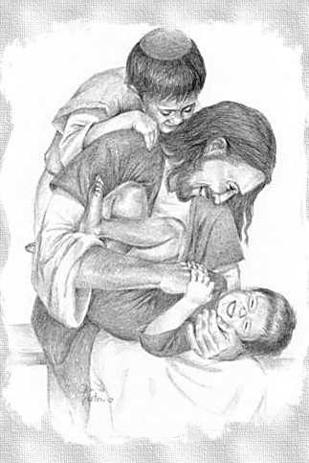**Because He Ascended, *He can save anyone and everyone along with every need***

“Wherefore h _ i _ a _ _ _ also t _ s _ _ _ t _ _ _ t _ t _ _ u _ _ _ _ _ _ _ _ t _ _ _ c _ _ _

u _ _ _ G _ _b _ h _ _, seeing he ever liveth to make intercession for them.”

***Hebrews 7:25***

* **The Lord’s Ascension *causes us to draw near with true hearts***

“Let us d _ _ _ n _ _ _ w _ _ _ a t _ _ _ h _ _ _ _ in f _ _ _ a _ _ _ _ _ _ _ _ o _ f _ _ _ _, having our hearts sprinkled from an evil conscience, and our bodies washed with pure water.” ***Hebrews 10:22***

* **The Lord’s Ascension *gives believers a goal to look forward to***

“L _ _ _ _ _ _ u _ _ _ J _ _ _ _ the a _ _ _ _ _ and f _ _ _ _ _ _ _ of o _ _ f _ _ _ _; who for the joy that was set before him endured the cross, despising the shame, and is set down at the right hand of the throne of God.” ***Hebrews 12:2***

“I p _ _ _ _ t _ _ _ _ _ t _ _ m _ _ _ for the prize of the high calling of God in Christ Jesus.” ***Philippians 3:14***

* **The Lord Jesus Christ Ascended *that H might fulfill all things***

“He that descended i _ t _ _ s _ _ _ also t _ _ _ a _ _ _ _ _ _ _ up far above all heavens, that he m _ _ _ _ f _ _ _ a _ _ t _ _ _ _ _.)” ***Ephesians 4:10***

* **The Lord’s Ascension *became a coronation***

“W _ _ is g _ _ _ i _ _ _ h _ _ _ _ _, and is on the right hand of God; a _ _ _ _ _ and

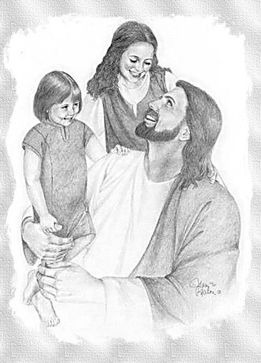a _ _ _ _ _ _ _ _ _ _ and p _ _ _ _ _ being m _ _ _ s _ _ _ _ _ _ u _ _ _ h _ _.”

***1 Peter 3:22***

* **The Ascension *became one of the Six articles of “the mystery of godliness”***

“And without controversy great is t _ _ m _ _ _ _ _ o _ g _ _ _ _ _ _ _ _: God was manifest in the flesh, justified in the Spirit, seen of angels, preached unto the Gentiles, believed on in the world, r _ _ _ _ _ _ _ u _ i _ _ _ g _ _ _ _.” ***1 Timothy 3:16***

* **A result of the Ascension is that *Jesus Christ is now highly exalted and every knee will bow to Him***

“Wherefore God also h _ _ _ h _ _ _ _ _ e _ _ _ _ _ _ h _ _, and g _ _ _ _ h _ _ a name

w _ _ _ _ i _ a _ _ _ _ every name: That at the name of Jesus e _ _ _ _ k _ _ _ s _ _ _ _ _ b _ _, of things in heaven, and things in earth, and things under the earth; And that

e _ _ _ _ t _ _ _ _ _ s _ _ _ _ _c _ _ _ _ _ _ that J _ _ _ _ C _ _ _ _ _ i _ L _ _ _, to the glory of God the Father.” ***Philippians 2:10, 11***

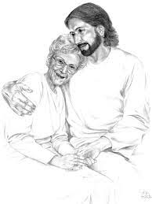We now conclude our study on the Ascension of the Lord Jesus Christ. We are to go believing what the Holy Scriptures have taught us. Jesus’ next appointment from the Bible is to call out the Church from off this earth to go be with Him. As sure as He went, so will we. If He had the power to Ascend, which He did, then He has the power to make us ascend. Are you ready? It could be today! There is nothing stopping the Rapture from happening this instant. Will you go, or will you be left? This is not a question to leave unanswered. If you are not sure, after prayer go talk with the teacher and get this matter settled. Do not wait! God bless you for your courage. Christian, let us be busy, and our Lord find us waiting. Thank you for studying with us.

The Ascension of Christ