Lesson #

Christology-Miracles of the Lord Jesus Christ

3

Lesson Commenced: ____________________ Lesson Completed: ____________________

* In this lesson we will study the Miracles of Christ. This subject has for centuries been the battleground for unbelievers. The so-called educated minds of today attempt to solve the dispute by just pretending that they did not happen. Because they can neither understand or prove them, they reject them.

* The believer on the other hand accepts the miracles of Jesus Christ because he has faith in a miracle working God. A true believer’s first “proof” of a miracle working God is, of course, the new birth itself. Nothing could be more miraculous than the new birth. Why in the world would any man who has experienced the new birth doubt the miracles of Jesus Christ? The new birth, in itself, is a miracle. It is kind of understandable from a saved persons viewpoint why a lost person would question the miracles of the Lord, not having experienced a miracle to point to in their own life.

* The word “miracle” is used very loosely today. Someone survives a terrible car wreck and another call it a “miracle” when it was not a miracle at all, it was “divine providence.” Whether they will admit it or not, or give Him the glory or not, they know it was not a “miracle.” So, then, what does the word miracle mean? A simple definition is***, “the setting aside of a lower law, by a higher law, the higher law being a law of God which supersedes earth’s laws.*** For example, an apple falls down according to the law of gravity, but if it fell up that would be a miracle. It would be the power of God superseding and changing the “law of gravity.”

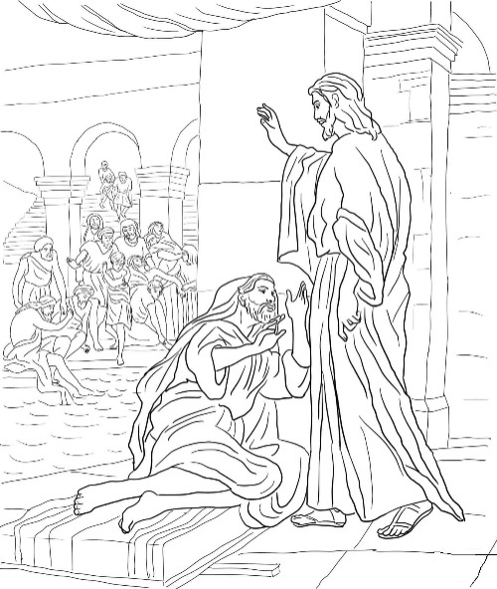* The unbeliever gets into an airplane and it takes off. They say “airflow’ and “aerodynamics” and “feathering” and “props” and “lift” and “stabilizers” and the “vacuum” and “uplift”and blabbobdy, blah, blah. It never occurs to them that a higher law comes into play when the plane takes off the ground, and this law is worked out by sinners that do not have the capacity to comprehend “God.” Here’s how a “scholar would put it. “It’s an effect in nature not attributable to any of the recognized operations in nature, nor the act of man, but indicative of super human power and serving as a sign or witness thereof.” Huuuhhh? In Acts 4, the Jewish council and the Holy Spirit called the healing of the forty-year-old man that never walked a “miracle” when he walked, because ordinarily, they don’t walk.

“Be it known unto you all, and to all the people of Israel, that b _ t _ _

n _ _ _ o _ J _ _ _ _ C _ _ _ _ _ of Nazareth, whom ye crucified, whom God

raised from the dead, even b _ h _ _ doth this man s _ _ _ _ h _ _ _ before

you w _ _ _ _.” ***Acts 4:10***

“Saying, What shall we do to these men? for t _ _ _i _ _ _ _ _ a n _ _ _ _ _ _

m _ _ _ _ _ _ hath b _ _ _ d _ _ _ by them is manifest to all them that dwell in

Jerusalem; and w _ c _ _ _ _ _ d _ _ _i _.” ***Acts 4:16***

* The uniqueness of “Jesus' miracles” is apparent. They were performed to “prove His deity” and “give credit to His message.” For these reasons, His miracles are debunked and disbelieved. Unbelievers do not want to confess Him as God (Deity) and, wish to take away His Sovereignty (Authority).

“This beginning of m _ _ _ _ _ _ _ d _ _ J _ _ _ _ in Cana of Galilee, and

m _ _ _ _ _ _ _ _ _ f _ _ _ _ h _ _ g _ _ _ _; and his disciples believed on him.”

***John 2:11***

* The prophets Moses, Aaron and Elijah performed miracles by power given by God for specific tasks. The Lord Jesus Christ performed His miracles by His own power to demonstrate His “deity.” In all, Jesus performed thirty-five to forty miracles recorded in the gospels.

* Jesus, while being tempted by the devil refused to perform any miracles or to obey the devil to satisfy His hunger. When the Lord was brought before Herod the skeptic, He showed him absolutely nothing. That is one thing that is tremendous about our Lord is that He will not be manipulated by anyone, especially a dishonest unbelieving skeptic. Jesus offered an answer about an honest skeptic, but to Herod, nothing!

“If any m _ _ w _ _ _ d _ h _ _ w _ _ _, h _ s _ _ _ _ k _ _ _ of the doctrine, whether it

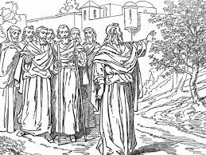be of God, or whether I speak of myself.” ***John 7:17***

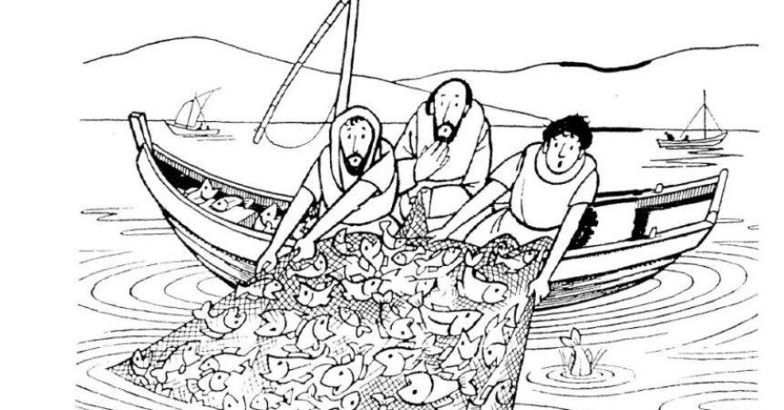Considering Jesus Christ’s Miracles

* **He performed Miracles over Nature**

“And he saith unto them, Why are ye fearful, O ye of little faith? Then he arose, and

r _ _ _ _ _ _ the w _ _ _ _ and t _ _ s _ _; and there was great calm. But the men marveled, saying, What manner of m _ _ I _ t _ _ _, that even the w _ _ _ _ and t _ _

s _ _o _ _ _ h _ _!” ***Matthew 8:26, 27***

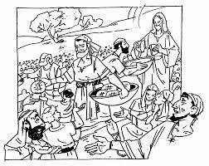The winds and the sea obey no man today. There is not an astronaut, sailor, aerologist, or meteorologist in the world, today, who controls any wind or sea. Man cannot and does not, no matter what he tries to come up with to do it, stop, change, or deter the weather when it has a mind to do something. Where’s all of these “faith healing miracle workers” when a category 5 hurricane rolls ashore. Answer? Headed North man, like everyone else, that’s where! Fakirs! Or, as the Holy Scriptures put it, “liars.”

* **He performed Miracles over devils**

Jesus had both powers to command devils to go out and to go in.

“And all the d _ _ _ _ _ b _ _ _ _ _ _ _ h _ _, saying, S _ _ _ u _i _ _ _ t _ _ s _ _ _ _, that we may e _ _ _ _i _ _ _ them. And forthwith J _ _ _ _ g _ _ _ t _ _ _ l _ _ _ _. And the unclean spirits went out, and e _ _ _ _ _ _i _ _ _ the swine: and the herd ran violently down a steep place into the sea, (they were about two thousand;) and were choked in the sea.” ***Mark 5:12, 13***

“And there was in their synagogue a man w _ _ _ a _ u _ _ _ _ _ _ s _ _ _ _ _; and he cried out, Saying, Let us alone; what have we to do with thee, thou Jesus of Nazareth? art thou come to destroy us? I know thee who thou art, the Holy One of God. And J _ _ _ _

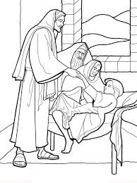r _ _ _ _ _ _ h _ _, saying, H _ _ _ t _ _ p _ _ _ _, and c _ _ _ o _ _ o _h _ _.And when the unclean spirit had torn him, and cried with a loud voice, h _ c _ _ _ o _ _ o _ h _ _.” ***Mark 1:23-26***

Other Scriptures also include ***Matthew 8:28-32, 9:33, 15:28, 17:18***.

* **He performed Miracles over Diseases**

He healed palsy – ***Matthew 8:13***

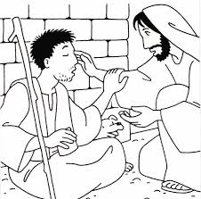He healed an impotent man - ***John 5:9***

He healed a wounded hand – ***Matthew 12:13***

He healed a spirit of infirmity – ***Luke 13:12***

He healed blood that would not coagulate – ***Matthew 9:22***

He healed dropsy – ***Luke 14:4***

He healed fever – ***Matthew 8:15***

He healed dumbness – ***Matthew 9:33***

He healed blindness – ***John 9:7***

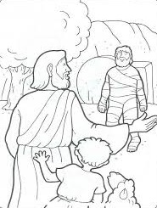He healed deafness – ***Matthew 11:5***

He healed leprosy – ***Matthew 8:3***

Jesus healed all of these without a prayer line, a healing line, a healing cloth, an organ, a tent, a truck, a radio program, and never took up a donation. As a matter of record, He healed so much look what this real Apostolic brother said.

“And there are also m _ _ _ o _ _ _ _ t _ _ _ _ _ w _ _ _ _ J _ _ _ _ d _ _, the which, if

they s _ _ _ _ _ b _ w _ _ _ _ _ _ every one, I suppose that even t _ _ w _ _ _ _

itself c _ _ _ _ n _ _ c _ _ _ _ _ _ t _ _ b _ _ _ _ that should be written. Amen.”

***John 21:25***

* **Other Miracles that the Lord Jesus Christ performed**

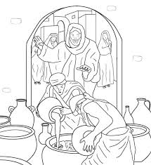Jesus turned water into wine – ***John 2:7-11***

Jesus feeds five thousand people – ***John 6:1-14***

Jesus feeds four thousand people – ***Matthew 15:32-39***

Jesus curses a fig tree which immediately withered – ***Matthew 21:18-20***

Jesus sends Peter fishing to pay their taxes –***Matthew 17:24-27***

Jesus walks on the sea – ***John 6:15-21***

* **He performed Miracles over Death**

He raised Lazarus from the dead – ***John 11***

He raised Jairus’ daughter from the dead – ***Matthew 9***

He raised the son of the widow of Nain from the dead – ***Luke 7:11-15***

He didn’t use any CPR, use any kind of medications or potions. The people that the Lord raised were already pronounced” DEAD” when He got to them.

But, what is most amazing, if that weren’t enough after three days, He walks out of a tomb that is guarded by Roman centurions, and sealed with an army-of occupation governor’s ring. His own resurrection was the greatest miracle of all.

“For I delivered unto you first of all that which I also received, how that C _ _ _ _ _

d _ _ _ for our sins a _ _ _ _ _ _ _ _ t _ t _ _ s _ _ _ _ _ _ _ _ _; And that h _ w _ _

b _ _ _ _ _, and that he r _ _ _ a _ _ _ _ the t _ _ _ _ d _ _ a _ _ _ _ _ _ _ _ t _ t _ _

s _ _ _ _ _ _ _ _ _:” ***1 Corinthians 15:3, 4***

“Forasmuch then as the children are partakers of flesh and blood, he also himself likewise took part of the same; that t _ _ _ _ _ _ d _ _ _ _ h _m _ _ _ _ d _ _ _ _ _ _ h _ _ that

h _ _ the p _ _ _ _ of d _ _ _ _, that is, t _ _ d _ _ _ _;” ***Hebrews 2:14***

“Knowing that Christ being r _ _ _ _ _ f _ _ _ t _ _ d _ _ _ d _ _ _ _ n _ m _ _ _; death hath no more d _ _ _ _ _ _ _ o _ _ _ h _ _. For in that he died, he died unto sin once: but in that he liveth, h _ l _ _ _ _ _ u _ _ _ G _ _.” ***Romans 6:9, 10***

“Whom God hath raised up, having loosed the pains of death: because it w _ _ n _ _

p _ _ _ _ _ _ _ t _ _ _ h _ s _ _ _ _ _ b _ h _ _ _ _ _ o _i _.” ***Acts 2:24***

* So, let’s stop just a moment and think. We can see from a brief examination of Jesus Christ the Lord’s miracles that there is something drastically wrong with the people that profess today to have apostolic power. We all can probably name somebody that we are familiar with today or we have known or heard of in the past that has claimed to have “supernatural” powers and the ability to exercise them. First, the Scriptures say that the signs were given to Israel. Secondly, the signs went out with the apostles. The surest proof these people trying to counterfeit or imitate something that they cannot produce is that none of them anywhere, at any time, in front of anybody has reproduced any of the things we have been over. There is not a case anywhere, where a so-called “healer” ever fed four or five thousand in the wilderness with a hand full of fishes and bread. There are no cases of any Charismatic, Pentecostal, or Holiness movements that were found at a graveyard bringing back to life a four-day old corpse that stunk. No, the ones that “claim” these powers today are fakirs and spoken of by the Apostle John in his writing. Look what he says they are.

“I know thy works, and thy labor, and thy patience, and how thou canst not bear them

w _ _ _ _ a _ _ e _ _ _: and thou hast t _ _ _ _ t _ _ _ which s _ _ t _ _ _ a _ _ apostles, and a _ _ n _ _, and hast found them l _ _ _ _:” ***Revelation 2:2***

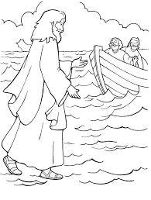By the way just for the record, we never find anyone that performed a miracle of any kind in the scriptures “trying to get the glory for themselves” or “charging anyone for the services being rendered to the needy.” The Lord said He was not going to share His glory with anybody else.

“I am the LORD: that is my name: and m _ g _ _ _ _ w _ _ _ I n _ _ g _ _ _ t _

a _ _ _ _ _ _, neither my praise to graven images.” ***Isaiah 42:8***

Enough said!

* As to the credibility of Jesus’ miracles: Jesus’ miracles are the basis for belief or disbelief of the New Testament and cannot be separated from it. The records of the Lords miracles are not sensational or glowingly presented. They are just presented in a matter-of-fact way. Most of them were performed openly and in front of many witnesses for all to see. Unless the Lord specifically prescribed a situation because of someone’s unbelief, there were no private audiences. Jesus had nothing to hide even though He could have if He had wanted to. It was all done in the open.

Jesus’ miracles were instantaneous and effective immediately. Nobody had to be part of the prayer line, or have a card, or be worked into a frenzy. Bam! Done!

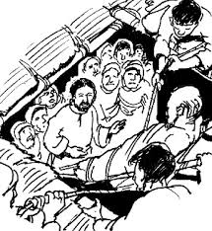* All of the efforts of intellectual skeptics to explain the Lord’s miracles outside of belief and faith, were and are, bamboozled. The Lord said ain’t nobody figuring out anything unless He says so.

“Let no man d _ _ _ _ _ _h _ _ _ _ _ _. If any man among you seemeth to be wise in this world, let him become a fool, that he may be wise. For the w _ _ _ _ _ of t _ _ _ w _ _ _ _ is

 f _ _ _ _ _ _ _ _ _ _ with God. For it is written, He t _ _ _ _ _ t _ _ w _ _ _ in their o _ _

c _ _ _ _ _ _ _ _ _.” ***1 Corinthians 3:18, 19***

“I know that, whatsoever God doeth, it shall be for ever: nothing c _ _ b _ p _ _ t _i _, nor a _ _ t _ _ _ _ t _ _ _ _ f _ _ _ i _: and God doeth it, that men s _ _ _ _ _ f _ _ _ b _ _ _ _ _ h _ _.” ***Ecclesiastes 3:14***

* In closing, as far as the miracles performed by the Lord are concerned, let’s believe like the old southerner once put it who said, “I believe the whale swallowed Jonah because the Bible say’s so, but if the Bible said Jonah swallowed the whale, I would believe that too.”

“God forbid: yea, let God be true, but every man a liar; as it is written, That thou mightest be justified in thy sayings, and mightiest overcome when thou art judged.” ***Romans 3:4***

Miracles of the Lord Jesus Christ! Amen.