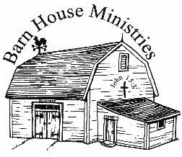Lesson #

Bibliology-The Symbols of the Bible

3

Lesson Commenced: ____________________ Lesson Completed: ____________________

*Symbol* - Something visible that by association or convention represents something else that is invisible; Express indirectly by an image, form, or model; Represent or identify by using a symbol.

* There are seven main symbols in the Bible used to illustrate the word of God. These are, a ***sword***, a ***hammer***, a ***seed***, a ***mirror***, a ***fire***, a ***lamp***, and ***food***. We will also see several others the Bible uses. As we cannot survive physically without literal food and water for a literal body in need, likewise we cannot survive spiritually without literal food and water for a spiritual body in need. The Bible represents and is illustrative of spiritual needs that the spiritual man must have. The Bible is the all-around fulfillment for the spiritual man’s health. Let’s study.

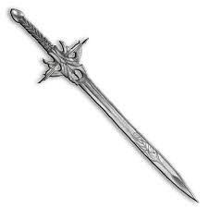

1. **The Bible is likened to a *Sword***

The Bible is a pointed word that convicts the hearer.

“For the w _ _ _ o _ G _ _ is quick, and powerful, and sharper than any twoedged

s _ _ _ _, piercing even to the dividing asunder of soul and spirit, and of the joints and marrow, and is a discerner of the thoughts and intents of the heart.” ***Hebrews 4:12***

Man with Hammer.tif

1. **The Bible is likened to a *Hammer.***

The Bible is powerful and breaks the resistance of the hearer.

“Is not m _ w _ _ _ like as a fire? saith the LORD; and l _ _ _ a h _ _ _ _ _

that breaketh the rock in pieces?” ***Jeremiah 23:29***

Gardening 01.tif

1. **The Bible is likened to a *Seed***

The Bible is the living word, regenerating the hearer

“Being born again, not of c _ _ _ _ _ _ _ _ _ _ s _ _ _, but of i _ _ _ _ _ _ _ _ _ _ _ _, by

the w _ _ _ o _ G _ _, which l _ _ _ _ _ and abideth for ever.” ***1 Peter 1:23***

1. **The Bible is likened to a *Mirror***

The Bible is a faithful reflection revealing the individual to himself.

“But be ye doers of the word, and not hearers only, deceiving your own selves. For if any be a hearer of the word, and not a doer, he is like unto a man b _ _ _ _ _ _ _ _ h _ _

n _ _ _ _ _ _ f _ _ _ i _ _ g _ _ _ _: For he beholdeth himself, and goeth his way, and straightway forgetteth what manner of man he was. But whoso l _ _ _ _ _ _ i _ _ _ t _ _

p _ _ _ _ _ l _ _ o _ l _ _ _ _ _ _, and continueth therein, he being not a forgetful hearer, but a doer of the work, this man shall be blessed in his deed.” ***James 1:22-25***

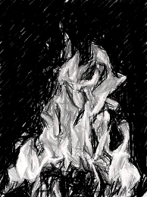In the above verse we have the Bible likened to a mirror in which the sinner or saint looks and sees a true picture of himself, as portrayed by his creator.

1. **The Bible is likened to a *Fire***

The Bible is a burning word that consumes the dross in the hearer.

“Is not m _ w _ _ _ l _ _ _ a _ _ f _ _ _? saith the LORD; and like a hammer

that breaketh the rock in pieces?” ***Jeremiah 23:29***

“Then I said, I will not make mention of him, nor speak any more in his name. But h _ _ w _ _ _ was in mine heart a _ _ b _ _ _ _ _ _ f _ _ _ shut up in my bones, and I was weary with forbearing, and I could not stay.” ***Jeremiah 20:9***

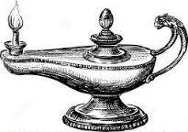

1. **The Bible is likened to a *Lamp***

The Bible is an illuminating word, guiding the believer day by day.

“T _ _ w _ _ _ i _ a l _ _ _ unto my feet, and _ l _ _ _ _ unto my path.” ***Psalms 119:105***

1. **The Bible is likened to *food***

**Apple 3.tif**

* **It is like *Apples***

It is words to the wise.

A w _ _ _ fitly spoken i _ l _ _ _ a _ _ _ _ _ of gold in pictures of silver.”

***Proverbs 25:11***

* **Cow 07.tifIt is like *Milk***

The Bibles words are sustenance to help us grow.

“As newborn babes, desire the s _ _ _ _ _ _ m _ _ _ o _ t _ _ w _ _ _, that ye m _ _

g _ _ _ thereby:” ***1 Peter 2:2***

Cow 14.tif

* **It is like *Meat***

The Bibles words are mature food to help us to discern and be skillful and strong.

“For every one that useth milk is unskilful i _ t _ _ w _ _ _ o _

r _ _ _ _ _ _ _ _ _ _ _ _: for he is a babe. But s _ _ _ _ _ m _ _ _ belongeth to them that are of full age, even those who by reason of use have their senses exercised to discern both good and evil.” ***Hebrews 5:13,14***

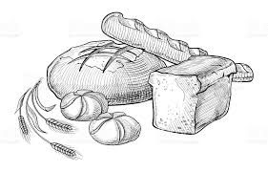

* **It is like *Bread***

The Bible supplies all the spiritual energy needed for the believer.

“But he answered and said, It is written, Man shall not live b _ b _ _ _ _

a _ _ _ _, but by e _ _ _ _ w _ _ _ that proceedeth out of the m _ _ _ _ o _ G _ _.” ***Matthew 4:4***

* **It is like *Honey***

The Bible is sweet to those that love it.

“The fear of the LORD is clean, enduring for ever: the j _ _ _ _ _ _ _ _ o _ t _ _

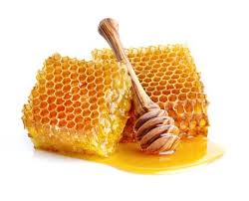L _ _ _ are true and righteous altogether. More to be desired are they than gold, yea, than much fine gold: s _ _ _ _ _ _ also than h _ _ _ _ and t _ _

h _ _ _ _ _ _ _ _.” ***Psalms 19:9, 10***

* Now do you realize what we have just gone over? These truths give a man complete survival equipment. If you were put out in a jungle, desert, or forest with the equipment listed, you could live just as long as any man living anywhere in the world. You would have apples, honey, bread, meat, milk, a sword, a hammer, seed to plant, a mirror to signal with, fire to boil water and cook food and a lamp to see with at night. What else would you need except maybe nails?

“The w _ _ _ _ o _ t _ _ w _ _ _ are as goads, and a _ n _ _ _ _ fastened by the

m _ _ _ _ _ _ of assemblies, which are given from one shepherd.” ***Ecclesiastes 12:11***

The Bible is “the Book of Books” and cannot be out done. Because Its Author cannot be out done. What other book do you know of that compares itself with the perfect diet of “life” in this world and the one to come. “…I know not any.” ***Isaiah 44:8***

Bibliology-The Symbols of the Bible